SCADA and Operator Data Reporting System
Manual



Table of Contents

1. Report Manual Overview 3

1.1 Document Objectives 3

1.2 Document Organization 3

2. HISTORICAL Reports Overview 4

3. Launching the Report Application 5

4. Entering Operator Data 7

4.1 Comment Data Entry 7

4.2 Other Data Entry 8

5. Demanding Reports 9

6. Automatically Printing Reports 10

7. REPORT SETUP AND CONFIGURATION 11

7.1 PLC Tag Setup 11

7.1.1 Tag Setup Details 13

7.1.2 Tag Setup Demand Report 15

7.2 OPERATOR Tag Setup 16

7.2.1 Adding New Tags 17

7.2.2 Tag Setup Details 18

7.2.3 Tag Setup Demand Report 20

8. Summary Reports Sample 21

9. Detailed Reports Sample 22

Report Manual Overview

Document Objectives
This document describes the Dakins Reporting System used to report SCADA and operator entered data.

Document Organization
The manual is organized as follows:
- Overview describing the reporting system
- How to enter operator data
- How to demand a report
- How to configure for auto printing of reports
- How to configure the format of the report
The Overview and Launching sections are good for anyone unfamiliar with this reporting system.
The section on Entering Operator Data describes how to enter pre-configured non-SCADA data into the reports (e.g. comments).
The section on Demanding Reports describes how to call up a report for any given day, month or year in any available format.
The section on Report Setup and Configuration provides details of how to add operator data fields and how to change the grouping or order and format of information on the reports.

HISTORICAL Reports Overview
The historical reports consist of data from two different sources: PLC data and Operator Entered data.
The PLC data is data calculated every second in the PLC and summarized hourly. The hourly summaries are collected and stored for reporting. Information included is analyzer values (min / max / average / total) and equipment run times. The logging / reporting application is independent of the SCADA and is accessed by using the ‘Historical Reports’ button in the menu (See Topbar). Note that the configuration of PLC data calculations, collection and storage is not available to the user.
The Operator Entered data is data that is typed in by the operator such as comments or weather. Typically this data is daily data. The configuration of what is entered is available to the user, allowing the user to add more operator data at any time.

Launching the Report Application
The report application is launched by running the DataPresentation_Summary.mde file in the reports presentation folder (typically \@configfiles\reports\datapresentation on the data drive (c:, d: or e: typically).
When the reporting application is launched it displays a standard menu from which the user can enter data or launch daily, monthly or yearly reports in one of two styles, Summary reports or Detailed reports.
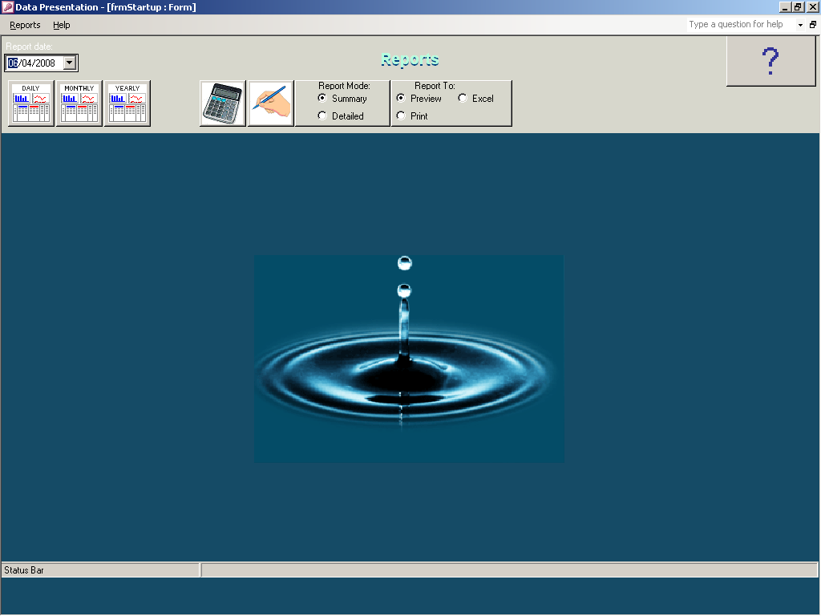
1
2
3
4
5
9
6
7
8
- Date Select. Used to select date / date range for required report. When drop down arrow is selected, calendar pops up to allow selection of desired date.
- Daily Report. When pressed, a daily report is generated from historical data for date selected in Date Select box.
- Monthly Report. When pressed, a monthly report is generated from historical data for month selected in Date Select box.
- Yearly Report. When pressed, a yearly report is generated from historical data for year selected in Date Select box.
- Operator Entered Numerical Data. When pressed, a data entry form is presented for all configured operator data entry items. Current date shown in date selection is used to timestamp data entered on this form.
- Operator Entered Comments. When pressed, a comment entry form is present for adding operator comments. Current date shown in date selection is used to timestamp data entered on this form.
- Report Mode. Option selects either Summary or Detailed report style.
- Report To. Option selects whether reports are sent to screen for preview, straight to printer or exported to Excel spreadsheet.
- About Button. Displays information about the reporting application.

Entering Operator Data
There are two different data entry pages, one for comments and one for other data (e.g. grab sample results).

Comment Data Entry
Comment data entry is pre-configured for comments. The data entry form can be opened by clicking on the icon that looks like a hand holding a pencil (item 6 in section above).
The data entry form shows comments recently entered and provides a large button for entering a new comment. When the button is pressed, the user is prompted to enter a new comment. Once entered, comments cannot be erased.
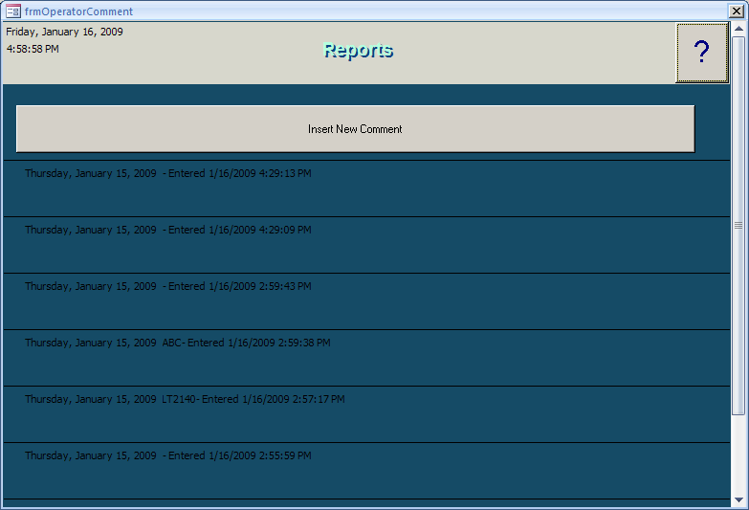

Other Data Entry
All other data entry can be configured by the user (see configuration section). The user can configure as many other data entry points as desired (e.g. chlorine grab sample reading locations, lab data results etc.).
The other data entry form can be opened by clicking on the icon that looks like a calculator (item 5 in section above). When the form is opened, each configured data entry point is available to be typed in.
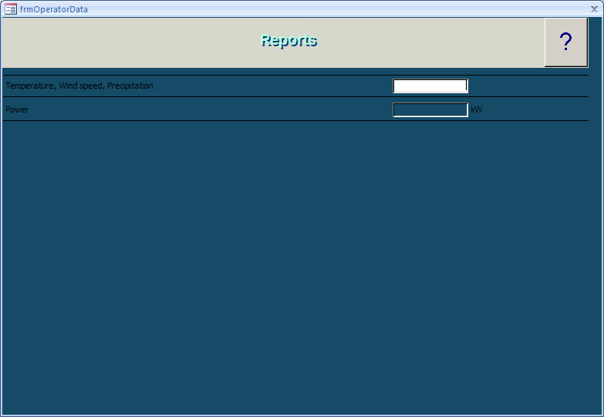

Demanding Reports
To demand a report the user must first decide what date, which type (summary or detail) and where to send the output. Then the operator can print a daily, monthly or yearly report.
First, the user selects the date for which the report is to be calculated. By default, when the report application is started, it defaults to a date of yesterday. To select a different date, enter a date in the date select field (item 1 in the section above) or use the pulldown arrow to enter via a calendar. Note that for a monthly report, the user can select any day in the month and for the yearly report the user can select any day in the year.
Second, the user selects which type of report is desired. There are two types of reports, summary and detail. The summary report calculates a single minimum, maximum, average and total for each data point (e.g. transmitter) for the entire reporting period (day, month or year). The detail report calculates minimum, maximum, average and total for each hour for the daily report, for each day for the monthly report and for each month for the yearly report. The selection is made in the report mode box (item 7 in the section above)
Thirdly, the user selects where to send the output. There are three possible destinations, preview, print or Excel. The preview destination allows the user to look at the report on the screen and to print out all or selected pages of the report. The print destination always prints the entire report to the default printer. The Excel destination exports the report data to Excel for the user to use further. The selection is made in the output to box (item 8 in the section above)
Finally, after making these selections, the operator clicks on the period for which the report is to be generated (daily monthly or yearly). These are icons item 2,3 and 4 respectively in the section above.

Automatically Printing Reports
Automatic printing of reports is simplified by a script file.
In the datapresentation folder (usually \@configfiles\reports\datapresentation on the data drive) is a script called PrintReports.vbs. This script will print to the default printer the oldest daily summary report prior to today that has not yet been printed (so if the computer is crashed for some time, it will print from where it left off. If all reports have already been printed, it will not print anything.
This script can be scheduled in Scheduled Tasks to run once a day. We suggest, however, that it be scheduled to run more than once a day (e.g. at 5:00, 5:30, 6:00 and 6:30) so that it can catch up if more than one previous daily report remains to be printed.

REPORT SETUP AND CONFIGURATION
There are two types of basics types of historical data, PLC data and Operator Data. (Operator data includes numerical data and text data). PLC data is automatically logged hourly from the PLC. Operator data is manually entered by the operator. Historical report configuration of both of these types of Data is accessed by selecting the appropriate setup option from the Reports menu.
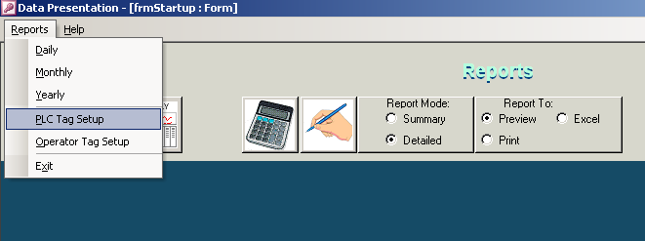

PLC Tag Setup
Selecting PLC Tag Setup displays a form showing all available PLC tags for display in a report. The list of tags is preconfigured and cannot be changed by the user.
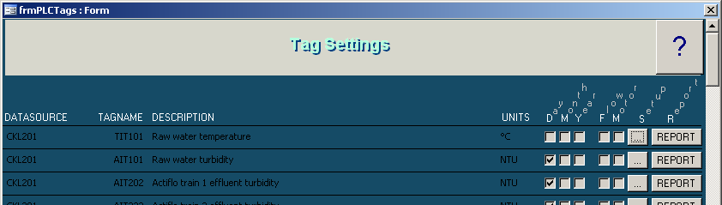
The Tag Settings form identifies the following information about each tag:
- DataSource. Where the tag data is from (Generally PLC Name)
- TagName. Instrument, Motor etc Name
- Description. Description of process measurement / equipment function.
- Units. Standard units of measurement used in raw data to report.
- Day / Month / Year. Identifies whether report is configured to display data for this tag daily, monthly, yearly.
- Flow. Identifies whether value is treated as flow. If it is a flow, it is possible to calculate total flow at report time.
- Motor. Identifies whether value is treated as motor. If it is a motor, only total run time (hours) is calculated at report time.
- Setup. When the ‘…’ button is pressed, the Reports – Tag Setup form is displayed..
- Report. When the ‘Report’ button is pressed the Reports - Demand Report form is displayed.

Tag Setup Details
The Settings button (“…”) on the Tag Settings form calls up a form that allows the user to configure individual report details for each tag including grouping, which reports it is displayed on (Daily, Monthly, Yearly), number of decimals to include.
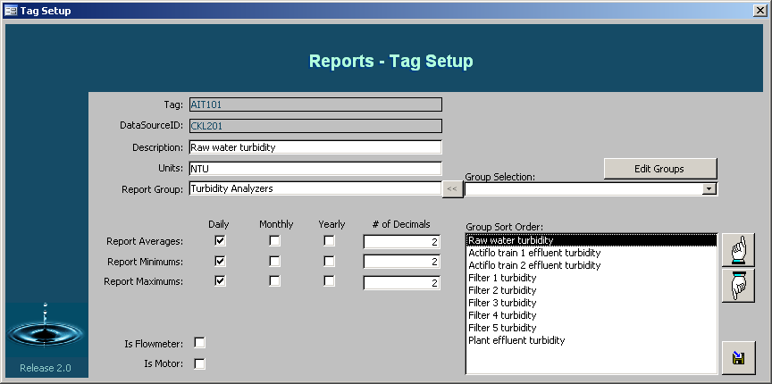

If the tag is a Flowmeter totalizer units as well as totalizer conversion factors are displayed as well as a selection of whether or not totals are shown.
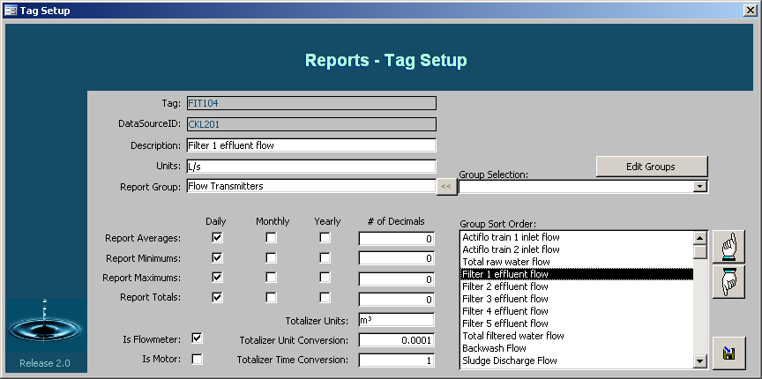
If tag is a motor (or other running equipment which should be treated like a motor to monitor run time), Only selection of whether hours are to be reported and how many decimals to display are shown.
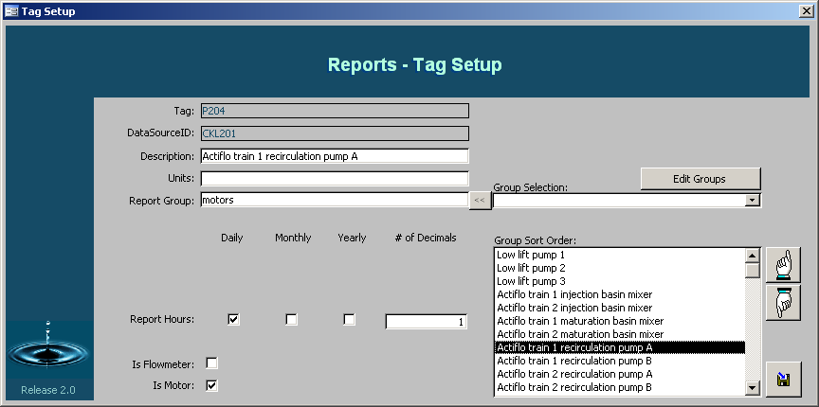

Tag Setup Demand Report
The Report button on the Tag Settings form calls up a form that allows the user to select generation of a report (Daily / Monthly / Yearly) for a single tag (the one shown). This can be a useful tool for quickly looking in history for data on a single tag without having to generate a whole report.
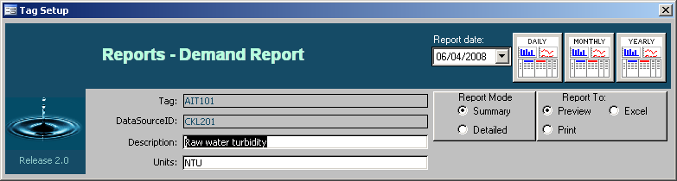

OPERATOR Tag Setup
Selecting Operator Tag Setup (From the Report menu on the main form) displays a form showing all available Operator tags for display in a report, as well as an entry box for adding new operator entered data tags.
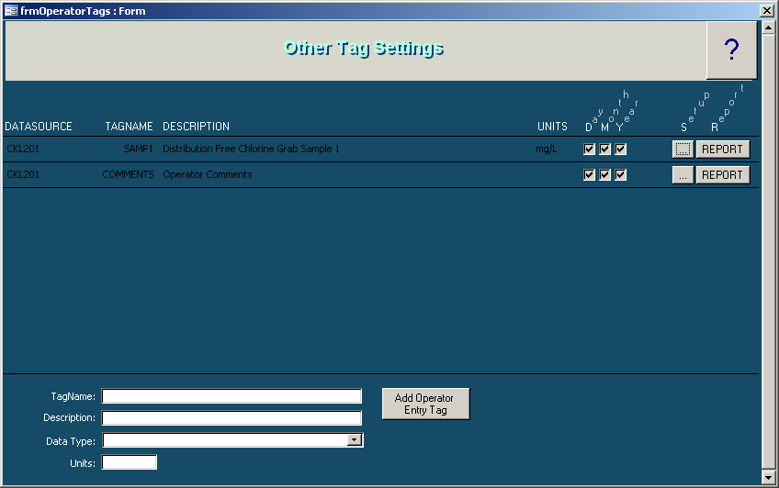
The Other Tag Settings form identifies the following information about each tag:
- DataSource. Where the tag data is from (Generally set the same as the closest associated PLC name to keep similar data on same report)
- TagName. Name of logged point.
- Description. Description of logged point.
- Units. Standard units of measurement used in entered data (no units required for string data).
- Day / Month / Year. Identifies whether report is configured to display data for this tag daily, monthly, yearly.
- Setup. When the ‘…’ button is pressed, the Reports – Tag Setup form is displayed..
- Report. When the ‘Report’ button is pressed the Reports - Demand Report form is displayed.

Adding New Tags
To add a new tag to the form, the user simply is required to fill out the appropriate fields and press the ‘Add Operator Entry Tag’ button.
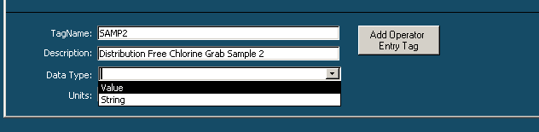

Tag Setup Details
The Settings button (“…”) on the Other Tag Settings form calls up a form that allows the user to configure individual report details for each tag including grouping, which report it is displayed on (Daily, Monthly, Yearly), number of decimals to include. The following example depicts the operator tag setup for numerical data.
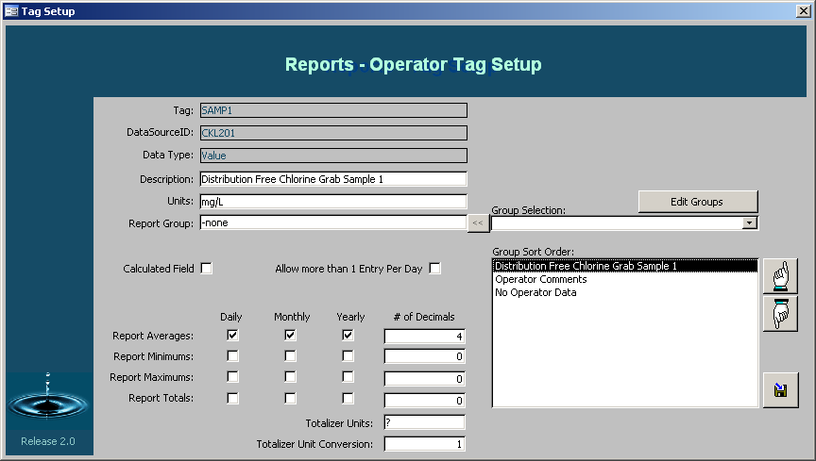
Most fields are similar to the report setup options for PLC Data with the following differences:
- Calculated Field. If the tag is a calculated field, it is automatically generated based on a scripted query (advanced property requiring supportive programming).
- Allow more than 1 Entry Per Day. If the tag is setup to allow more than 1 entry per day, the operator entry form will automatically show multiple entry fields for the data point (ie every time a value is entered a new blank prompt will be displayed for the point). If multiple entries are not enabled, only one entry is displayed.
The following example depicts the operator tag setup for text data. It is much simplified and only displays selection of whether or not the data will be displayed on the report or not (Daily / Monthly / Yearly).
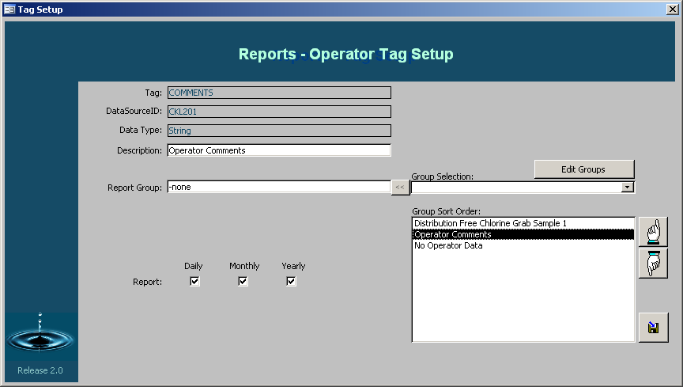

Tag Setup Demand Report
The Report button on the Other Tag Settings form calls up a form that allows the user to select generation of a report (Daily / Monthly / Yearly) for a single tag (the one shown). This can be a useful tool for quickly looking in history for data on a single tag without having to generate a whole report.

Summary Reports Sample
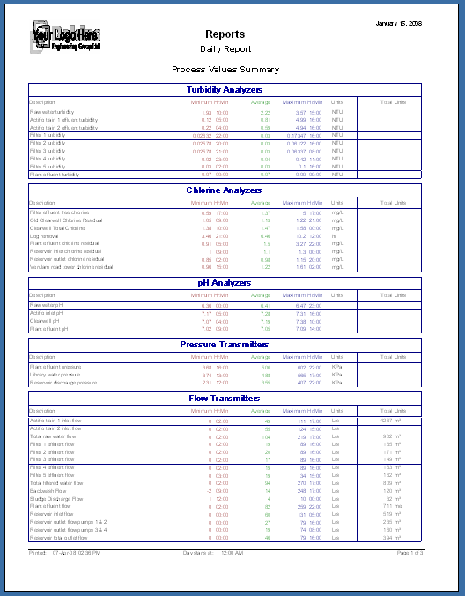
The summary report is a condensed version of the detailed report showing final data for the selected time period. Analyzers values are shown at the start of the report and sorted into process areas and Equipment runtimes are shown at the end of the report.

Detailed Reports Sample
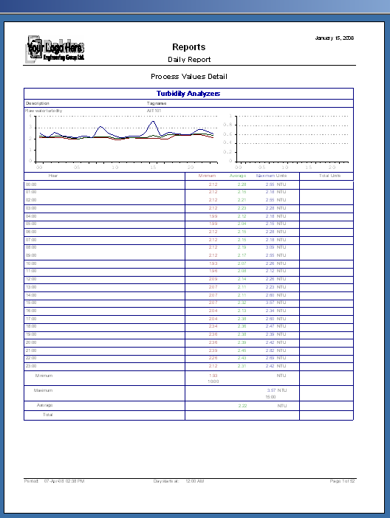
The detailed report displays detailed information which is listed depending on time duration of the report selected. The daily report displays values collected every hour for 24 hours, the monthly report displays daily values for the month and the yearly report displays monthly values for the selected year. Each page of the report displays information by process area and graphs are used to show relevant values over the time duration of the report. As in the summary report, process analyzer values are displayed at the beginning of the report and equipment run times are displayed at the end of the report.

